\Received 00th January 20xx,
- Department of Chemical and Biomolecular Engineering, Sogang University, Seoul 04107, Republic of Korea. ^{b}Institute of Emergent Materials, Sogang University, Seoul 04107, Republic of Korea. E-mail: kangms@sogang.ac.kr
Supplementary Information available: [HSP tables, RED values (OA-QD, MMES-QD and N-BP), previous results summary, chemical structures and NMR data, stability of QDs, control experiment, and AFM height profiles of patterns] See DOI: 10.1039/x0xx00000x
Accepted 00th January 20xx
DOI: 10.1039/x0xx00000x
Quantum dots with photopolymerisable ligands for green-solvent direct photolithography
Jin Ho Keum,ª Yongkook Kang,ª Se Young Parkª, Hyeokjun Kimª, SeungHwan Rohª, Yonghyun Jo,ª and Moon Sung Kang*^{a, b}

Recent advances in direct photolithography have enabled high-resolution patterning of quantum dots (QDs), offering a promising route toward next-generation display technologies. However, previously reported photopatterning strategies still rely on toxic organic solvents, which have severe environmental and industrial implications. Herein, we present a dual-ligand QD platform comprising a methacrylate-containing monomeric dispersing ligand that exhibits excellent compatibility with industrial green solvents and a benzophenone-based photoinitiating ligand that can initiate methacrylate polymerisation under i-line irradiation. This combination allows QDs to be dispersed in environmentally benign solvents, such as propylene glycol monomethyl ether acetate, diethylene glycol monoethyl ether acetate, 1-methoxy-2-propanol, and triethylene glycol monomethyl ether, while enabling fast, efficient, and non-destructive direct photolithography using standard i-line ultraviolet exposure. As a result, reliable 2 µm-resolution QD patterns can be achieved without compromising the intrinsic photoluminescence or electrical characteristics of the QDs.
1. Introduction
Colloidal quantum dots (QDs) have emerged as promising materials for next-generation displays owing to their narrow spectral bandwidth, tunable emission wavelengths, and high photoluminescence quantum yield (PLQY).¹⁻⁴ Indeed, QDs have already been commercialised as light emitters in the display industry. Initially, they were utilised as QD enhancement films to improve the quality of white light in liquid crystal displays. More recently, QD–polymer composites have been integrated onto blue organic light-emitting diodes (OLEDs) as colour conversion layers that convert the blue light from the OLEDs into red and green light.⁵⁻¹⁰ The next-generation QD displays are QD light-emitting diodes (QLEDs) where the QDs emit red, green and blue light via electrical excitation. QLEDs have garnered considerable attention due to their exceptional performance, such as a wide colour gamut, high brightness and external quantum efficiency (EQE).¹¹⁻¹⁹
Such excellent properties of QLEDs can be effectively leveraged in near-eye displays for extended reality (XR) applications. ^{5, 8} To achieve XR displays based on QLEDs, it is essential to develop high-resolution QD patterning processes that preserve optical properties. This pressing need for high-resolution patterning has generated significant interest in photolithographic methods for QD films, particularly direct photolithography, because of its simple patterning process and high-resolution patterning ability.^{20, 21} During the direct photolithography process, QD films are exposed to ultraviolet (UV) light to create a solubility contrast between the exposed and unexposed regions. By developing the unexposed regions, high-resolution patterns can be achieved without the use of photoresists. The key factor lies in triggering solubility contrast in QDs after UV irradiation through chemical reactions. Various strategies for inducing solubility contrast have been proposed, including the use of photosensitive ligands²¹⁻³⁰ and additives^{20, 31-35}. These strategies emphasise the importance of light-induced solubility changes in QDs for enabling direct photolithography. However, they do not address the toxicity of the processing solvents. The solubility of QDs is governed by the ligands attached to their surfaces; therefore, ligand engineering is vital in selecting appropriate processing solvents. Typically, QDs are capped with ligands containing relatively long hydrocarbon chains, such as dodecanethiol, oleylamine or oleic acid (OA), making them readily dispersible in only non-polar organic solvents such as chlorobenzene, chloroform and toluene. However, the toxicity of these solvents poses significant barriers to the commercialisation of QD-based technologies, underscoring the need for direct QD photopatterning processes that utilise green solvents.
Herein, we address this limitation by introducing a dual-ligand system composed of monomeric dispersing ligands (MDLs) and photoinitiating ligands (PILs).²¹ MDLs were incorporated to passivate most of the QD surface and identify the applicable solvents for QDs. Specifically, the MDL we utilised was mono-2-(methacryloyloxy)ethyl succinate (MMES), which consists of carboxylic acid and methacrylate at its ends, allowing the resulting QDs to disperse in green solvents such as propylene glycol monomethyl ether acetate (PGMEA), triethylene glycol monomethyl ether (TGME), diethylene glycol monoethyl ether acetate (DGMEA) and 1-methoxy-2-propanol (PGME). In addition, a small amount of PILs was also introduced; the PILs contain a benzophenone group capable of initiating the polymerisation of methacrylate in MDLs under i-line irradiation. By employing this dual-ligand QD system, we successfully achieved the formation of high-resolution line patterns with a spatial resolution of 2µm under i-line exposure through direct photolithography.
2. Results and discussion
2.1 Dual-ligand QD passivation system for green processing
As previously stated, as-synthesised QDs are only readily dispersible in nonpolar organic solvents, such as chloroform, dichlorobenzene, and toluene, because they are typically capped with OA ligands. However, these solvents raise significant environmental and regulatory concerns, which limit their applicability in industrial processes. To render QDs compatible with environmentally benign green solvents (PGMEA, TGME, DGMEA and PGME), a ligand-exchange process is required (Fig. 1a). We selected MMES as a promising ligand because it is structurally similar to the aforementioned solvents.³⁶ MMES not only offers excellent solvent compatibility but also features a methacrylate functional group, which enables radical polymerisation in the solid state. If radical polymerisation can be photoinitiated, it would enable the direct photopatterning of QDs, a technique that is garnering attention for the fabrication of high-resolution QD-based pixels.
A straightforward strategy may entail incorporating free photoinitiators into MMES-passivated QD (MMES-QD) inks. However, freely diffusing radicals generated upon photoinitiation may attack the QD surface, leading to undesirable degradation of their photoluminescence (PL).³⁴ To address this, we introduced a PIL in which the photoinitiating functional group is covalently tethered to the ligand backbone. This immobilisation suppresses the undesired mobility of photoinitiators, reducing their potential to impair QD optical properties. Specifically, we introduced a benzophenone-derived PIL, 2-((4-benzoylphenyl)(methyl)amino)ethyl 3-mercaptopropanoic acid [hereinafter abbreviated as N-BP], where the para-position of the benzophenone unit is substituted with an electron-donating nitrogen group (Fig. 1a). This substitution red-shifts the activation wavelength of the PIL from the deep UV region to the UV-A region, increasing the molar extinction coefficient up to 9950 M⁻¹cm⁻¹ at 365 nm (i-line) (Fig. 1b), a wavelength that is widely used in semiconductor and display manufacturing.²¹ Furthermore, the PIL backbone includes ester groups to maintain compatibility with green solvents and a thiol anchoring group to ensure QD surface coordination. It is worth noting that we previously reported photocrosslinkable ligands (PXLs) bearing similar benzophenone end groups.²¹ In that earlier study, the benzophenone moieties acted as direct crosslinking units by abstracting hydrogen atoms from neighbouring alkyl chains and forming ketyl-radical-mediated covalent linkages between adjacent QDs. In contrast, the present study reveals a completely different role of the benzophenone-bearing ligand, serving as PIL (despite having a similar chemical structure to the PXLs). When co-present with MMES, a polymerisable methacrylate ligand, the benzophenone unit functions primarily as a photoinitiator that initiates radical polymerisation of neighbouring MMES chains under UV exposure. This previously unrecognised ligand interplay shifts the role of benzophenone-bearing ligand from a direct crosslinker to a radical initiator. Importantly, this mechanistic advance enables substantially more efficient photopatterning at lower exposure doses, thereby reducing UV-induced damage (see below).
To confirm the excellent solubility of MMES and N-BP ligands in green solvents (PGMEA, DGMEA, TGME and PGME), we employed the Hansen solubility parameter (HSP) analysis, a method widely used to quantify interactions between polymers and solvents by measuring the dispersion force ($δ_{D}$), dipolar force ($δ_{P}$) and hydrogen bonding ($δ_{H}$). Parameters describing these interactions were obtained from an HSP calculation handbook.³⁷⁻⁴¹ Specicially, we performed a solubility parameter analysis on as-synthesised OA-capped QDs (OA-QDs), MMES-capped QDs (MMES-QDs), and N-BP ligands for various organic solvents, including the aforementioned green solvents (Fig. 1c). The solvents and their HSP values are listed in Tables S1–S3. The solubility parameter sphere for the OA-QDs (blue) was found to be centred at ($δ_{D}$, $δ_{P}$, $δ_{H}$) = (17.6, 1.3, 3.4), with a radius (R_{0, OA}) of 6.5. The solubility parameter sphere for the MMES-QDs (black) was centred at ($δ_{D}$, $δ_{P}$, $δ_{H}$) = (18.0, 5.8, 7.4), with a radius (R_{0, MMES}) of 8.0. Lastly, the solubility parameter sphere for N-BP (red) was centred at $(δ_{D}, δ_{P}, δ_{H})$= (18.0, 9.8, 11.7), with a radius (R_{0, N-BP}) of 11.3. Next, the solubility differences (R_{a}) between the QDs and the solvents were calculated using the equation R_{a}² = 4($δ_{D}$^{Material} − $δ_{D}$^{Solvent})² + ($δ_{H}$^{Material} − $δ_{P}$^{Solvent})² + ($δ_{H}$^{Material} − $δ_{H}$^{Solvent})². Moreover, the relative energy difference (RED) is defined as R_{a}/R₀. For any given material, a solvent with RED < 1 (the solvent lies inside the solubility sphere of the material) implies that it is a good solvent for the material. The HSP analysis revealed that the OA-QDs had a RED value greater than 1 for the selected green solvents, indicating that these solvents are unsuitable for processing OA-QDs. Conversely, the MMES-QDs and N-BP exhibited RED values less than 1 for the selected green solvents (Table S4). These results confirm that the HSP values of these solvents fall within the solubility sphere of each ligand, ensuring their excellent dispersion capability.
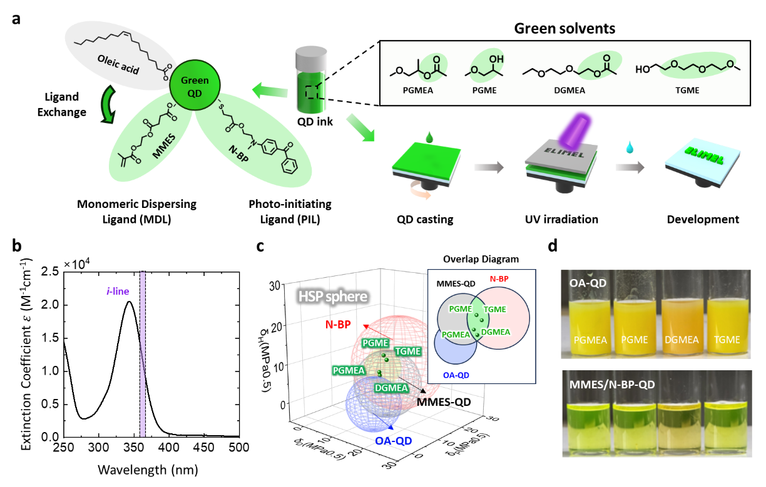
The PILs and MDLs were anchored directly onto the QD surface through a single-step ligand-exchange process. Specifically, dry OA-QD powder was mixed with 5 wt% PILs and 100 wt% MDLs (both relative to the QDs), along with a green solvent capable of dissolving both ligands. Although OA-QDs are inherently insoluble in these green solvents, continuous stirring for 3 h gradually facilitated the replacement of the native OA ligands with the introduced PIL and MDL molecules. Once sufficient ligand exchange had occurred, the resulting MMES/N-BP-QDs became fully dispersible in the green solvents and formed clear and stable dispersions. The upper panel in Fig. 1d shows OA-QDs poorly dispersed in the four representative green solvents, exhibiting significant turbidity due to poor solubility. Conversely, the lower panel shows MMES/N-BP-QDs well dispersed in the same solvents, appearing optically transparent. This clear contrast visually confirms the successful ligand exchange and the ensuing enhancement in green-solvent dispersibility.
Fig. 1 Formulation process for the green-solvent-soluble and i-line-sensitive QD ink. (a) Schematic of the ligand-exchange process, the introduction of the MDL and PIL, and the direct photopatterning process. (b) Molar extinction spectrum of the PIL. (c) HSP spheres of the OA-QDs (blue), MMES-QDs (black) and N-BP ligand (red) The inset diagram displays the overlapping solubility sphere of MMES and N-BP, which encompasses PGMEA, PGME, DGMEA and TGME. (d) Photographs of the OA-QDs (top) and MMES/N-BP-QDs (bottom) in PGMEA, PGME, DGMEA and TGME green solvents.
To verify the successful ligand exchange and quantify the composition of the newly introduced ligands, we conducted ¹H NMR spectroscopy on MMES/N-BP-QDs, MMES-QDs (without PILs) and the original OA-QDs (Fig. S1). The characteristic olefinic proton peak of OA at 5.4 ppm was markedly suppressed in both the MMES-QDs and MMES/N-BP-QDs, although it was clearly observed in the OA-QDs. Instead, new peaks emerged at 5.6 ppm and 6.2 ppm, which correspond to the vinyl protons of the newly incorporated MMES ligands. In the case of MMES/N-BP-QDs, an additional set o f peaks appeared in the aromatic region between 7.5 and 8.0 ppm, which can be assigned to the benzophenone moiety of the PIL. These spectral changes collectively confirm the displacement of the native OA by the functional MMES and N-BP ligands. The surface composition of the QDs was further quantified by integrating the characteristic proton signals of each ligand species. The results demonstrated that the MMES/N-BP-QDs comprised approximately 80 mol% MMES, 11 mol% PIL and a residual 9 mol% OA, validating the formation of the intended dual-ligand MMES/N-BP-QD structure.
2.2 Optical properties of the MMES/N-BP-QDs
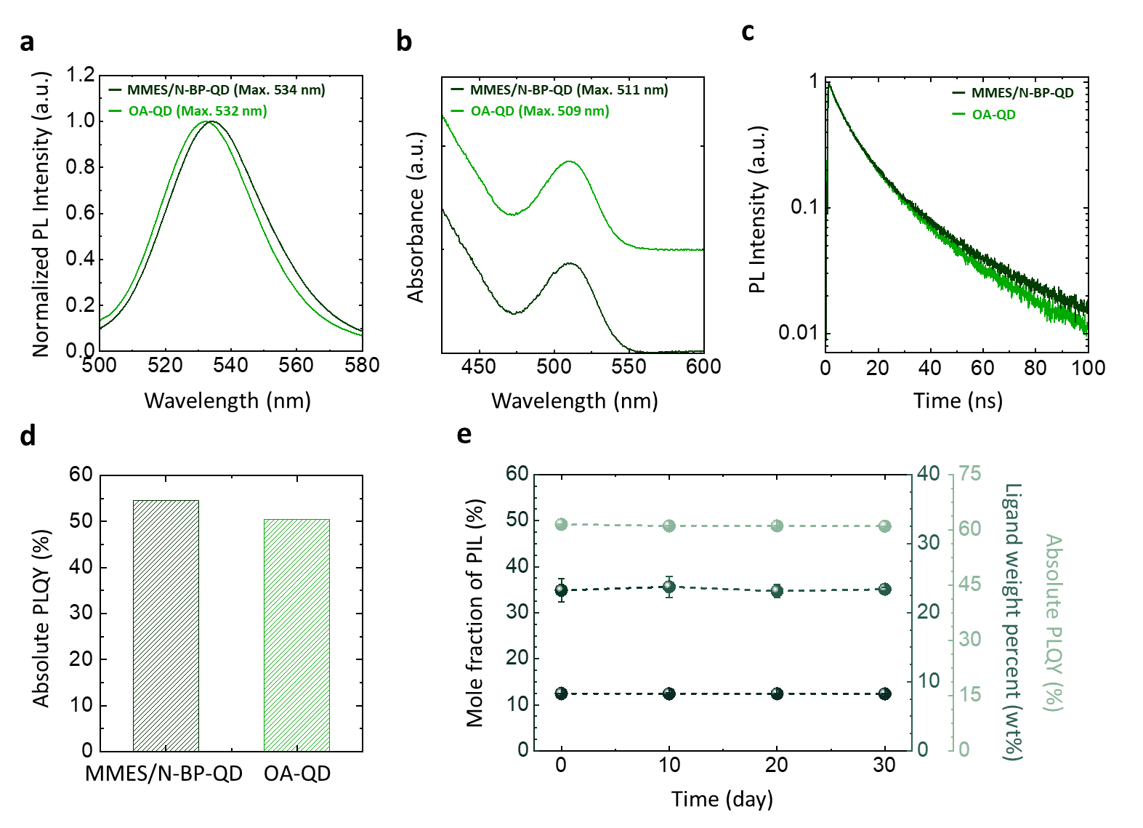
The optical properties of the synthesised MMES/N-BP-QDs were subsequently evaluated and compared with those of the original OA-QDs. As shown in Figs. 2a and 2b, the PL and UV–Vis absorption spectra of both samples in film form exhibit minimal differences. The film-state PL emission peaks appeared at 532 nm for the OA-QDs and 534 nm for the MMES/N-BP-QDs. This slight red-shift is likely due to a modest change in QD packing density caused by the replacement of the relatively long OA ligands with the shorter MMES ligands. Similarly, the first excitonic absorption features exhibited only a minor shift from 509 nm (OA-QDs) to 511 nm (MMES/N-BP-QDs), indicating negligible alterations in the QD band structure. To further investigate the excitonic recombination dynamics, transient PL (TrPL) measurements were conducted (Fig. 2c). The exciton lifetime of the OA-QD film was 9.8 ns, whereas that of the MMES/N-BP-QD film was 9.9 ns, which represents a 1% increase relative to the OA-QD value. In agreement with this observation, absolute PLQY measurements conducted immediately after ligand exchange revealed an increase from 50% to 55% for the MMES/N-BP-QDs (Fig. 2d). This increase can be attributed to the improved surface passivation provided by the thiol anchoring group of the N-BP ligand, which effectively coordinates to the ZnS shell.²⁶ The MMES/N-BP-QDs also demonstrated excellent long-term stability under ambient conditions (Fig. 2e). Over a 30-day period, three key parameters were monitored: the mole fraction of the surface-bound PIL determined via ¹H NMR spectroscopy, the overall ligand mass fraction measured using thermogravimetric analysis (TGA), and the absolute PLQY of the QDs. All three parameters exhibited minimal variation throughout the testing period, confirming the robust chemical and optical stability of the dual-ligand QDs under ambient storage conditions. To further evaluate the storage stability of the dual-ligand QD ink, we monitored its photophysical properties after storage under harsh environmental con ditions. Specifically, the MMES/N-BP-QD ink dispersed in PGMEA was stored at an elevated temperature (85 °C) under ambient conditions (i.e., in the presence of oxygen and atmospheric pressure) for 12 hours.⁴²⁻⁴⁴ Despite this rigorous thermal and oxidative stress, the dual-ligand QDs exhibited an excellent PLQY retention of 85.8% relative to their initial value, with no significant alterations observed in either the peak emission wavelength or the full width at half-maximum (FWHM). Notably, this robust retention in the luminescence characteristics is highly comparable to that of the pristine OA-QDs dispersed in toluene (Fig. S2). Furthermore, these results clearly indicate that the introduced dual ligands remain stably anchored to the QD surface without undergoing severe heat-induced desorption, even within a green solvent environment.
Fig. 2 (a) Comparison of PL spectra for MMES/N-BP-QD and OA-QD films. (b) Comparison of absorbance spectra for MMES/N-BP-QD and OA-QD films. (c) Comparison of TrPL decay profiles for MMES/N-BP-QD and OA-QD films. (d) Comparison of the absolute PLQY values for MMES/N-BP-QD and OA-QD films. (e) Long-term storage stability of the MMES/N-BP-QD ink: surface ligand composition (analyzed via NMR and TGA) and absolute PLQY. The ink was stored in the cabinet under the following conditions: a temperature of 3℃, a relative humidity (RH) of 20–40%, and atmospheric pressure (1 atm). (Error bar represents the standard deviation.)

2.3 Polymerisation of MDLs triggered by the PILs
Upon i-line (365 nm) irradiation, MMES/N-BP-QD films cast from PGMEA exhibited a dramatic change in solubility. As shown in Fig. 3a, the UV-exposed regions of the film became completely insoluble in PGMEA, whereas the unexposed regions dissolved readily. This solubility contrast results from the photopolymerisation of the surface ligands initiated by the benzophenone moiety in the PIL. Under i-line irradiation, the benzophenone group abstracts hydrogen from a nearby hydrocarbon chain, generating a ketyl radical and a carbon-centred radical (initiation step in Fig. 3b). The resulting ketyl radical or carbon-centred radical (predominantly the latter) subsequently attacks the vinyl group of the methacrylate unit on the MMES ligand, cleaving the C=C bond and forming a new carbon-centred radical.⁴⁵ This radical subsequently adds to the vinyl groups of neighbouring MMES ligands, producing a rapidly propagating chain-growth polymerisation (propagation step in Fig. 3b). The resultant crosslinked polymeric network effectively immobilises the QDs within an insoluble matrix, thereby preventing dissolution in the developing solvent. The polymerisation process ultimately terminates through radical–radical recombination or disproportionation (termination step in Fig. 3b), resulting in the final formation of an insoluble, photopolymerised QD film.^{46, 47}
To verify the reaction, Fourier-transform infrared (FT-IR) spectroscopy was performed on the MMES/N-BP-QD films before and after UV irradiation. As shown in Fig. 3c, the characteristic absorption peak of the vinyl C=C bond at 1637 cm⁻¹ was clearly present in the MMES/N-BP-QD film before polymerisation.^{36, 48} This peak completely disappeared after UV exposure (dose = 4.8 J cm⁻²), confirming that the vinyl groups were consumed during polymerisation. This result demonstrates that the proposed chain-growth mechanism induces rapid crosslinking, distinguishing it from previously reported PXL-based methods.
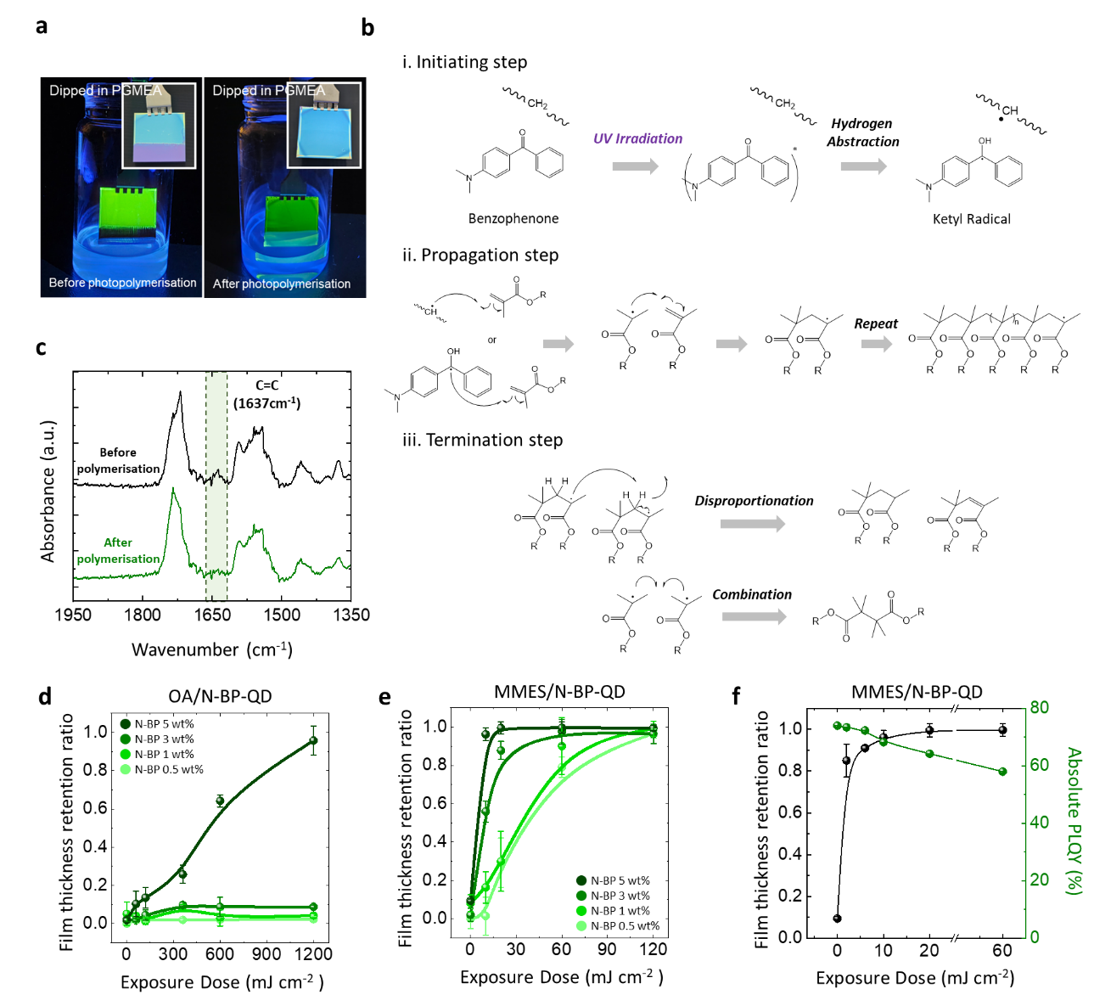
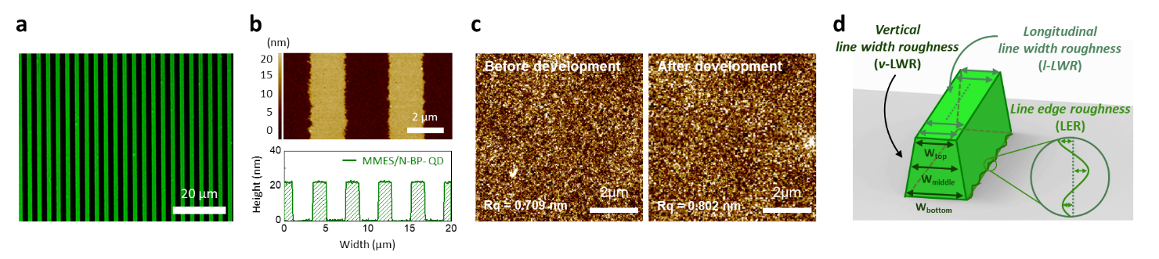
To provide additional evidence that the crosslinking of MMES/N-BP-QDs is caused by N-BP-initiated radical polymerisation of the methacrylate groups rather than the direct photochemical reactivity of the PIL itself, we conducted a series of comparative experiments. First, we prepared two QD samples containing an identical molar ratio of N-BP: one incorporating MMES as the MDL (MMES/N-BP-QDs) and another incorporating OA as the secondary ligand (OA/N-BP-QDs), which lacks a polymerisable acrylate moiety. In the latter case, the only possible photochemical pathway is hydrogen abstraction by benzophenone, followed by a slower radical coupling process between the N-BP-derived radicals and the alkyl chains of OA. Therefore, N-BP can serve only as a PXL. After preparing films of both QDs, we exposed them to identical UV doses under nitrogen and compared their film thickness retention ratios (FRRs). While the N-BP ligand failed to produce a fully crosslinked network in the OA/N-BP-QDs, even with a high loading of 5 wt% at a UV dose of 100 mJ cm⁻² (Fig. 3d), the MMES/N-BP-QDs exhibited complete crosslinking (FRR > 0.95) under a significantly low UV dose (10 mJ cm⁻²) (Fig. 3e). To further substantiate that the reaction proceeds via chain-growth polymerisation, we conducted additional FRR tests under ambient conditions using the same PIL concentration. Chain-growth polymerisation is notoriously susceptible to oxygen inhibition, as oxygen rapidly scavenges propagating radicals to form stable peroxy radicals, whereas crosslinking driven by simple radical coupling is significantly less sensitive to such quenching effects.⁴⁹ Indeed, the OA/N-BP-QDs system exhibited negligible differences in dose-dependent crosslinking efficiency between inert and ambient environments. Conversely, the crosslinking efficiency of the MMES/N-BP-QD system deteriorated dramatically under ambient conditions; the exposure dose required to achieve an FRR exceeding 0.95 increased dramatically by over an order of magnitude (Fig. S3). These experimental results unequivocally demonstrate that the crosslinking of MMES/N-BP-QDs is driven by chain-growth polymerisation rather than rapid radical coupling. This stark contrast demonstrates that crosslinking is dominated by the rapid chain-growth polymerisation of the methacrylate groups on MMES, rather than by the slow radical coupling reactions inherent in OA/N-BP-QDs. Such rapid and efficient polymerisation is critical for preserving the intrinsic PL characteristics of QDs, which are otherwise susceptible to degradation under prolonged UV exposure. As shown in Fig. 3f, the PL performance decreased as the UV dose increased; therefore, achieving FRR > 0.95 at a low exposure dose of 10 mJ cm⁻² is highly advantageous. Under this optimised condition, the MMES/N-BP-QD films retained over 90% of the pristine absolute PLQY while achieving near-complete crosslinking. It is worth noting that a similar PR-free strategy has previously been demonstrated using ligands that simultaneously impart green-solvent dispersibility and photocrosslinkability to QDs. However, because that system did not employ a separate photoinitiator, crosslinking relied on radicals generated directly from the ligand under relatively strong UV exposure. Consequently, a significantly higher exposure dose was required to induce effective pattern formation (150–300 mJ cm⁻²), which may compromise the optical properties of QDs. By contrast, our PIL-assisted system promotes radical polymerisation much more efficiently, enabling successful photopatterning at substantially lower exposure doses (50–60 mJ cm⁻²). This reduction in dose is particularly important for preserving the emission characteristics of UV-sensitive QDs, as demonstrated here for InP-based systems.
Fig. 3 (a) Photographs of a non-photopolymerised QD film (left) and photopolymerised MMES/N-BP-QD film (right). Both films were partially dipped in PGMEA, which is the mother solvent that can dissolve QD films. (b) Schematic illustration of the photopolymerisation mechanism of the dual-ligand QDs. (i) Initiation: Under UV irradiation, benzophenone generates a ketyl radical and a carbon-centred radical via hydrogen abstraction. (ii) Propagation: The ketyl radical or carbon-centred radical attacks the vinyl group of MMES. The newly formed radical continues the propagation process. (iii) Polymerisation terminates with disproportionation or combination of two radicals. (c) FT-IR spectra before (black) and after photopolymerisation (green). (d) FRR as a function of exposure dose for OA-QDs with different PIL concentrations (wt%). (e) FRR as a function of exposure dose for MMES/N-BP-QDs with different PIL concentrations (wt%). (f) Exposure dose-dependent FRRs and PLQY retention of the MMES/N-BP QDs with 5wt% N-BP. (Error bar represents the standard deviation.)
Fig. 4 Photopatterning of QDs with the dual-ligand system and analysis of the patterns. (a) Fluorescence OM image of 2 µm/2 µm line-width/space QD patterns. (b) Corresponding AFM image and height profile of the patterns. (c) Comparison of the surface roughness of the QD film before and after the development process. (d) Illustration of the LER, l-LWR and v-LWR.

2.4 Direct photopatterning of the dual-ligand QDs
The UV-induced photopolymerisation of the MMES ligands, initiated by the PIL, generated a well-defined solubility contrast in the QD films, allowing for direct photopatterning through selective exposure using a photomask. The overall photopatterning process involves three key steps: (i) coating of the MMES/N-BP-QD ink—dissolved in green solvents—onto a desired substrate, (ii) selective i-line UV exposure through a photomask and (iii) development of QD patterns using methylbenzoate to remove the unexposed, non-crosslinked regions (Fig. 1a). We employed this process to successfully fabricate high-resolution QD line patterns with a linewidth of 2 μm and a height of 20 nm, as shown in Fig. 4a. This specific height of 20-25 nm was tailored for the emissive layer (EML) in QLED applications.^{15, 18} Because the pattern height depends on the thickness of the initially deposited QD film, desired heights can be obtained simply by controlling the casting process. For example, we successfully demonstrated the fabrication of QD patterns with thicknesses of several hundred nanometers without relying on any additional resin (Fig. S4).
To further evaluate the pattern quality, atomic force microscopy (AFM) measurements were conducted (Fig. 4b). The AFM height profile confirmed the formation of well-defined and uniform QD lines (Fig. 4b). Notably, the root-mean-square roughness (R_{q}) of the crosslinked MMES/N-BP-QD films remained nearly unchanged after development (only increasing from 0.709 nm to 0.802 nm), indicating that development did not induce additional surface roughening (Fig. 4c). Quantitative analysis of pattern fidelity was performed following the statistical framework.³⁵ Three key parameters were evaluated: line-edge roughness (LER), longitudinal line-width roughness (l-LWR) and vertical line-width roughness (v-LWR) (Fig. 4d). The MMES/N-BP-QD photopatterning process yielded an LER of 83.7 ± 2.12 nm, an l-LWR of 121.0 ± 5.83 nm and a v-LWR of 171.95 ± 4.33 nm. These values represent 3 sigma (3σ) values of deviations, which encompass 99.7% of the measured values. They indicate minimal variation in the pattern dimensions; in particular, the measured LER is comparable to that of previously reported direct-photopatterning materials processed using non-green aromatic solvents.^{29, 34} Overall, these results confirm that high-resolution and high-fidelity QD patterns can be reliably produced through the proposed direct photopatterning approach without relying on toxic organic solvents.

2.5 Electroluminescence characteristics
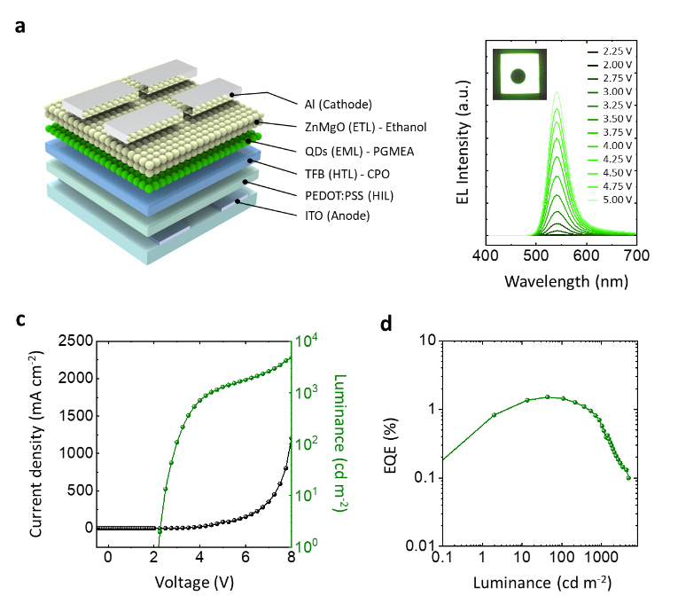
To evaluate the practical applicability of the green-solvent-processable QDs in electroluminescent devices, we fabricated a normal-structured QLED using the dual-ligand MMES/N-BP-QDs as the emissive layer (Fig. 5a). The device structure consisted of indium–tin oxide (ITO; 150 nm), poly(ethylenedioxythiophene):polystyrenesulfonate (PEDOT:PSS; 50 nm), poly(9,9-dioctylfluorene-co-N-(4-(3-methylpropyl))diphenylamine) (TFB; 30 nm) as the hole-transport layer (HTL), the QD emissive layer (20 nm) (which underwent UV exposure at 365 nm and 60 mJ cm⁻² under an inert atmosphere), ZnMgO nanoparticles (NPs) (75 nm) as the electron-transport layer (ETL), and an aluminium cathode (120 nm). Importantly, all solution-processed layers—including the HTL, QD layer, and ETL—were deposited entirely using green solvents, completely eliminating the use of conventional hazardous solvents. Specifically, TFB was dispersed in cyclopentanone (CPO), a well-known green solvent, rather than chlorobenzene. The QD ink was formulated in PGMEA, and the ZnMgO NPs were dispersed in ethanol.³⁹ The voltage-dependent electroluminescence spectra revealed that the MMES/N-BP-QD-based devices exhibited a stable emission peak at 543 nm with a full width at half-maximum of 42 nm (Fig. 5b). As shown in Figs. 5c and 5d, the devices exhibited a turn-on voltage of 2.2 V, a maximum luminance of 4818 nits and a peak EQE of 1.5%, which is, to the best of our knowledge, the first report of Cd-free QLEDs in which all active layers, including the charge transport/injection layers and the emissive layer, were entirely solution-processed using green solvents. Previous QDs patterning strategies (partially) employing green solvents are summarized in Table S5 and S6. Collectively, these results highlight the strong potential of the dual-ligand MMES/N-BP-QD and green solvent-based TFB platform for environmentally sustainable QLED applications.
Fig. 5 Structure and electroluminescence performance of QLEDs incorporating HTLs processed with various solvents. (a) Schematic of the QLED device structure. (b) Evolution of the electroluminescence spectra as the driving voltage increased for a representative device (HTL solvent: CPO). The inset displays a photograph of a working pixel. (c) Luminance–voltage vs. current density and (d) EQE–luminance characteristics of the QLEDs. The devices incorporated MMES/N-BP-QDs with the HTL dissolved in CPO.
3. Conclusions
In this study, we developed a dual-ligand QD platform that allows for direct and high-resolution photopatterning in industrially relevant green solvents. By integrating a methacrylate-containing MDL (MMES) with a thiol-anchored, benzophenone-based PIL, we achieved efficient ligand crosslinking in the platform under standard i-line (365 nm) exposure while preserving its excellent solubility in environmentally benign solvents such as PGMEA, DGMEA, PGME and TGME. We elucidated a rapid and efficient crosslinking mechanism driven by chain-growth polymerisation of the methacrylate groups on MMES, which contrasts clearly with conventional radical coupling mechanisms used in prior photopatterning approaches. This mechanism was experimentally validated through kinetic analysis and FT-IR measurements, which confirmed the consumption of vinyl groups following UV irradiation. Leveraging this ligand design, we demonstrated uniform and well-defined QD line patterns with 2 μm resolution and excellent pattern fidelity. Finally, the practical utility of the material system was confirmed by employing the system to fabricate QLEDs through a fully green-solvent, all-solution-processed workflow. The resulting devices validated the compatibility of the dual-ligand QDs with optoelectronic device fabrication. Overall, this dual-ligand strategy provides a commercially relevant pathway to environmentally sustainable, high-resolution QD patterning and holds tremendous promise for next-generation display and augmented/virtual reality applications.
4. Experimental Section
4.1 Materials
Ethanol, PGMEA (>99.5%), DGMEA (99%), TGME, PGME (99.5%), CPO (>99%), methyl benzoate, CDCl₃ (99.8%) and MMES were purchased from Sigma-Aldrich. InP/ZnSe_{X}S_{1-X}/ZnS was purchased from UNIAM. TFB was purchased from Montreal Optoelectronics Inc. Glass substrates with ITO patterns were purchased from AMG (Republic of Korea), PEDOT:PSS (Al4038) waspurchased from Ossila and Al was purchased from iTASCO. Additionally, 4-fluorobenzophenone, 2-(methylamino)ethanol and 3-mercaptopropionic acid were purchased from Tokyo Chemical Industry Co., Ltd. Magnesium sulphate (MgSO₄) and p-toluenesulphonic acid (PTSA) were purchased from Samchun Pure Chemical Co., Ltd. Ethyl acetate was purchased from Daejung Chemicals & Metals. Co., Ltd. ZnMgO NPs were synthesised using an ultrasonic-assisted method described in the literature.⁵⁰

4.2 Synthesis of N-BP
A mixture of 4-fluorobenzophenone (500 g) and 2-(methylamino)ethanol (200–300 mL) was charged into a reaction flask and heated to 150 °C while being stirred under reflux overnight. After cooling to room temperature, the reaction mixture was diluted with water and brine and subsequently extracted with ethyl acetate. The organic layer was separated and washed twice. The collected organic layer was dried over anhydrous MgSO₄, filtered and concentrated under reduced pressure. The resulting residue was dried in a convection oven at 70 °C for 48 h to yield the intermediate as a turbid yellow powder. The synthesised intermediate (10 g, 39.1 mmol), 3-mercaptopropionic acid (6.3 g, 59.3 mmol) and PTSA (0.8 g, 4.2 mmol) were dissolved in toluene (100 mL). The reaction mixture was heated to 125 °C and refluxed overnight using a Dean–Stark apparatus to remove the water generated during condensation. After the reaction was complete, the mixture was allowed to cool to room temperature and diluted with ethyl acetate and water. The organic layer was separated, dried over anhydrous MgSO₄ and filtered. The solvent was removed under reduced pressure, and the crude product was further dried under high vacuum to afford the final product as a dark green viscous liquid.

4.3 Ligand-Exchange Process
To prepare the photo-curable QD ink, the initial OA-QD dispersion in octane was first dried in a vacuum oven to remove the solvent, yielding OA-QD powder. This powder was then redispersed in PGMEA containing MMES (equal weight ratio to OA-QDs) and the N-BP ligand (5 wt% with respect to the OA-QDs). The mixture was stirred at room temperature for over 3 h until a transparent homogeneous solution was obtained. The resulting ligand-exchanged QDs were purified via precipitation with excess hexane to remove residual ligands and subsequently redispersed in PGMEA.

4.4 Direct Photopatterning Process
A thin film of MMES/N-BP-QDs (20 mg mL⁻¹) was formed on a SiO₂ wafer via spin coating. Thereafter, the film was selectively exposed to i-line UV light (365 nm) through a photomask, which rendered the exposed regions insoluble due to photocrosslinking. The final pattern was developed by removing the unexposed, soluble regions through sonication in the original solvent (e.g. PGMEA), resulting in QD patterns.

4.5 QLED Fabrication
The QLED devices were fabricated using ITO/PEDOT:PSS/TFB/QD/ZnMgO/MoO₃/Al layers. The Al electrode was deposited through thermal evaporation, while the remaining layers were fabricated through solution processing on ITO-patterned glass substrates. These glass substrates were sequentially cleaned with acetone, isopropyl alcohol and distilled water. A PEDOT:PSS (Al4083) solution was spin-coated (4000 rpm, 40 s) on the ITO-patterned glass substrates that were pretreated with UV-O₃. The film was then annealed at 150 °C for 30 min under ambient conditions. Subsequently, a TFB solution (6 mg mL⁻¹ dissolved in CPO) was spin-coated onto the PEDOT:PSS layer (4000 rpm, 30s), which was then annealed in a glove box at 150 °C for 30 min. QDs (20 mg mL⁻¹ in PGMEA) were thereafter spin-coated (2000 rpm, 40 s) onto the TFB layer and were heated at 120 °C for 30 min. Next, ZnMgO NPs (25 mg mL⁻¹ in ethanol) were spin-coated onto the QD layer at 3000 rpm for 30 s and were heated at 80 °C for 30 min. Finally, Al was thermally evaporated onto the ZnMgO NP layer at deposition rates of 1 Å s⁻¹ and 30 Å s⁻¹.

4.6 Measurement and Characterisation
The FT-IR spectra were acquired using an FT-IR4700 (Jasco) in attenuated total reflection mode on bare Si substrates. The surface morphology and height profile of the EML patterns were measured using a Park XE7 AFM system (Park Systems). The UV–Vis spectra were acquired using a V-770 UV–Vis/NIR spectrophotometer (Jasco). The PL spectra were acquired using an FS-2 fluorescence spectrometer (Scinco). The absolute PLQY was measured using a Quantaurus-QY absolute PLQY spectrometer (Hamamatsu Photonics). TrPL analysis was conducted using a time-correlated single photon counting (TCSPC) system. The ¹H NMR data were acquired using Spinsolve 80 (Magritek). The fluorescence images of the EML patterns were captured using an optical microscope under 365 nm UV light irradiation (Nikon). The electroluminescence characteristics of the OLEDs were evaluated using a PR 655 spectroradiometer (JADAK) while the input voltage was swept using a Keithley 2400.
Author contributions
J.K. contributed to experimental data collection, analysis, and writing the original draft. Y.K., S.P., H.K., S.R. and Y.J. contributed to data collection and analysis. M.S.K. supervised the entire project.
Data availability
The data supporting this article have been included in the article and supplementary information (SI). SI includes HSP tables (OA-QD, MMES-QD, N-BP), RED values (OA-QD, MMES-QD and N-BP), chemical structures and NMR data of N-BP, MMES ligands. SI is available. See DOI : XXXX
Acknowledgements
This work was supported by the Ministry of Trade, Industry, and Resources (MOTIR) of Korea (RS-2024-00440884).

References
1. F. P. García de Arquer, D. V. Talapin, V. I. Klimov, Y. Arakawa, M. Bayer and E. H. Sargent, Science, 2021, 373, eaaz8541.
2. J. Lim, M. Park, W. K. Bae, D. Lee, S. Lee, C. Lee and K. Char, ACS Nano, 2013, 7, 9019-9026.
3. J. Lim, W. K. Bae, D. Lee, M. K. Nam, J. Jung, C. Lee, K. Char and S. Lee, Chem. Mater., 2011, 23, 4459-4463.
4. W. K. Bae, M. K. Nam, K. Char and S. Lee, Chem. Mater., 2008, 20, 5307-5313.
5. Y. Wang, Y. Luo, X. Kong, T. Wu, Y. Lin, Z. Chen and S. Wang, Nanoscale, 2025.
6. G. Li, M.-C. Tseng, Y. Chen, F. S.-Y. Yeung, H. He, Y. Cheng, J. Cai, E. Chen and H.-S. Kwok, Light Sci Appl, 2024, 13, 301.
7. Z. Gao, J. Shi and G. Yang, Adv. Opt. Mater., 2024, 12, 2401106.
8. J. Chen, Q. Zhao, B. Yu and U. Lemmer, Adv. Opt. Mater., 2024, 12, 2300873.
9. H. Park, D. Hahm, H. Cho, J.-W. Shin, C.-m. Kang, D.-H. Ahn, C. W. Joo, B.-H. Kwon, K. Kim, J. Y. Kim, B. G. Jeong, N. S. Cho, W. K. Bae, J. Lee and S. Choi, ACS Appl. Opt. Mater., 2023, 1, 289-297.
10. B.-R. Hyun, C.-W. Sher, Y.-W. Chang, Y. Lin, Z. Liu and H.-C. Kuo, J. Phys. Chem. Lett., 2021, 12, 6946-6954.
11. Y. Kim, T. Lee, B. Chun, J. Kim and J. Kwak, ACS Photonics, 2025.
12. Y. Park, M. Lee, H. Seo, D. Shin, D. Hahm, W. K. Bae, J. Kim and J. Kwak, J. Mater. Chem. C, 2024, 12, 7270-7277.
13. Y. Kim, T. Lee, D. Shin, W. K. Bae and J. Kwak, ACS Appl. Nano Mater., 2024, 8, 307-314.
14. S.-Y. Joe, B. Yoon, D. Shin, W. K. Bae, S.-S. Lee and H. Lee, ACS Appl. Mater. Interfaces, 2024, 16, 46486-46494.
15. P. Yu, S. Cao, Y. Shan, Y. Bi, Y. Hu, R. Zeng, B. Zou, Y. Wang and J. Zhao, Light Sci Appl, 2022, 11, 162.
16. T. Lee, B. J. Kim, H. Lee, D. Hahm, W. K. Bae, J. Lim and J. Kwak, Adv. Mater., 2022, 34, 2106276.
17. T. Kim, K.-H. Kim, S. Kim, S.-M. Choi, H. Jang, H.-K. Seo, H. Lee, D.-Y. Chung and E. Jang, Nature, 2020, 586, 385-389.
18. Y.-H. Won, O. Cho, T. Kim, D.-Y. Chung, T. Kim, H. Chung, H. Jang, J. Lee, D. Kim and E. Jang, Nature, 2019, 575, 634-638.
19. W. K. Bae, Y.-S. Park, J. Lim, D. Lee, L. A. Padilha, H. McDaniel, I. Robel, C. Lee, J. M. Pietryga and V. I. Klimov, Nat Commun, 2013, 4, 2661.
20. J. Yang, D. Hahm, K. Kim, S. Rhee, M. Lee, S. Kim, J. H. Chang, H. W. Park, J. Lim, M. Lee, H. Kim, J. Bang, H. Ahn, J. H. Cho, J. Kwak, B. Kim, C. Lee, W. K. Bae and M. S. Kang, Nat Commun, 2020, 11, 2874.
21. D. Hahm, J. Lim, H. Kim, J.-W. Shin, S. Hwang, S. Rhee, J. H. Chang, J. Yang, C. H. Lim, H. Jo, B. Choi, N. S. Cho, Y.-S. Park, D. C. Lee, E. Hwang, S. Chung, C.-m. Kang, M. S. Kang and W. K. Bae, Nat. Nanotechnol., 2022, 17, 952-958.
22. P. Xiao, J. Ma, Z. Zhang, Y. Zou, H. Luo, J. Guan, J.-r. Zhang, L. Zhou, W. Hou, P. Zhang, D. V. Talapin and Y. Wang, ACS Nano, 2025, 19, 14509-14520.
23. J. Lee, S. Yeon, B. Koo, B. Sohn, S. J. Park, C. Kim and H. Cho, ACS Energy Lett., 2024, 10, 94-101.
24. J. Ko, K. Ma, J. F. Joung, S. Park and J. Bang, Nano Lett., 2021, 21, 2288-2295.
25. J. Ko, J. H. Chang, B. G. Jeong, H. J. Kim, J. F. Joung, S. Park, D. H. Choi, W. K. Bae and J. Bang, ACS Appl. Mater. Interfaces, 2020, 12, 42153-42160.
26. J. Lee, J. Ha, H. Lee, H. Cho, D. C. Lee, D. V. Talapin and H. Cho, ACS Energy Lett., 2023, 8, 4210-4217.
27. Z. Fu, L. Zhou, Y. Yin, K. Weng, F. Li, S. Lu, D. Liu, W. Liu, L. Wu, Y. Yang, H. Li, L. Duan, H. Xiao, H. Zhang and J. Li, Nano Lett., 2023, 23, 2000-2008.
28. J.-A. Pan, H. Wu, A. Gomez, J. C. Ondry, J. Portner, W. Cho, A. Hinkle, D. Wang and D. V. Talapin, ACS Nano, 2022, 16, 16067-16076.
29. H. Cho, J. A. Pan, H. Wu, X. Lan, I. Coropceanu, Y. Wang, W. Cho, E. A. Hill, J. S. Anderson and D. V. Talapin, Adv. Mater., 2020, 32, 2003805.
30. Y. Wang, I. Fedin, H. Zhang and D. V. Talapin, Science, 2017, 357, 385-388.
31. N. Lee, D. Choi, K.-J. Ko, H.-S. Kim, J. H. Yu and J.-S. Lee, ACS Nano, 2025.
32. Z. Fu, S. F. Musolino, W. Qing, H. Li, F. J. de Zwart, Z. Zheng, M. Cai, Y. Gao, B. de Bruin, X. Dai, J. E. Wulff and H. Zhang, J. Am. Chem. Soc., 2024, 146, 28895-28905.
33. S. Shin, K. Kang, H. Jang, N. Gwak, S. Kim, T. A. Kim and N. Oh, Small Methods, 2023, 7, 2300206.
34. J. Yang, M. Lee, S. Y. Park, M. Park, J. Kim, N. Sitapure, D. Hahm, S. Rhee, D. Lee, H. Jo, Y. H. Jo, J. Lim, J. Kim, T. J. Shin, D. C. Lee, K. Kwak, J. S. Kwon, B. Kim, W. K. Bae and M. S. Kang, Adv. Mater., 2022, 34, 2205504.
35. D. Liu, K. Weng, S. Lu, F. Li, H. Abudukeremu, L. Zhang, Y. Yang, J. Hou, H. Qiu, Z. Fu, X. Luo, L. Duan, Y. Zhang, H. Zhang and J. Li, Sci. Adv., 2022, 8, eabm8433.
36. D. Hahm, J. Park, I. Jeong, S. Rhee, T. Lee, C. Lee, S. Chung, W. K. Bae and S. Lee, ACS Appl. Mater. Interfaces, 2020, 12, 10563-10570.
37. S.-H. Lee, H.-B. Kim, J.-B. Kim, E.-y. Choi and J.-K. Song, Opt. Mater., 2025, 159, 116692.
38. S. Y. Park, S. Lee, S. Lee, J. Kim, K. Char and M. S. Kang, Small, 2024, 20, 2306366.
39. H. B. Kim, J. I. Yoo, S. C. Kang and J. K. Song, Small, 2024, 20, 2304051.
40. M. Díaz de los Ríos and E. Hernández Ramos, SN Appl. Sci., 2020, 2, 676.
41. C. M. Hansen, Hansen solubility parameters: a user's handbook, CRC press, 2007.
42. Y. H. Kim, S. Koh, H. Lee, S.-M. Kang, D. C. Lee and B.-S. Bae, ACS Appl. Mater. Interfaces, 2019, 12, 3961-3968.
43. Y. Fu, D. Kim, W. Jiang, W. Yin, T. K. Ahn and H. Chae, RSC advances, 2017, 7, 40866-40872.
44. H. Y. Kim, D.-E. Yoon, J. Jang, D. Lee, G.-M. Choi, J. H. Chang, J. Y. Lee, D. C. Lee and B.-S. Bae, J. Am. Chem. Soc., 2016, 138, 16478-16485.
45. J.-P. Fouassier and J. Lalevée, Photoinitiators for polymer synthesis: scope, reactivity, and efficiency, John Wiley & Sons, 2012.
46. Y. Nakamura and S. Yamago, Macromolecules, 2015, 48, 6450-6456.
47. M. Buback, F. Günzler, G. T. Russell and P. Vana, Macromolecules, 2009, 42, 652-662.
48. Y. Li, A. Alam, T. Zhou, C. Wang, Y. Wang and T. Li, Adv. Funct. Mater., 2025, 35, 2413963.
49. R. Simič, J. Mandal, K. Zhang and N. D. Spencer, Soft Matter, 2021, 17, 6394-6403.
50. H. Ban, Y. Choi, H. G. Lee, W. H. Jung, J. Lim and S.-Y. Cho, ACS Appl. Nano Mater., 2024, 7, 11274-11284.

